ADDIS ABABA UNIVERSITY
DEPARTMENT OF MATHEMATICS
Math. 325 Mid-exam.(Reg)

Name ________________________________________  ID.No. ________________  Section : ______________  Instructor’s Name: ____________________________  Date: may18, 2011  Time allowed 2 hrs | For instructor’s use only
 | Part I
 | P  a  r  t  II | 1
 | P  a  r  t  II | 2
 | P  a  r  t  II | 3
 | P  a  r  t  II | 4
 | Total

► This exam booklet contains 6 short answer questions and 4 workout

problems.

Part I. Give the precise and simplified short answer on the space provided.
[1.5 points each]

- If A and B are orthogonal vectors such that 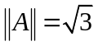 and 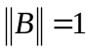, then the angle between vectors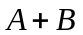 and 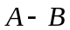 is _____________

- If a nonzero vector A makes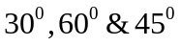 from the positive 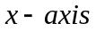,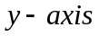 and
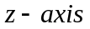respectively and , then  = _____________

- If 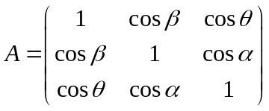 where 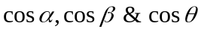 are directional cosines of a vector in 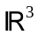.Then det= _____________

- Given matrices A and B of size 3x3. If detA = 4 and detB = -3 ,then det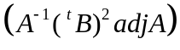=____________________

- Given vectors A=(1,1,1), B=(2,1,0) and C=(0,3,1), then 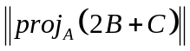= ________

- The eigenvalues of the matrix A = 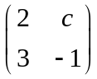 are -4 and c-1.
Then c = _______________

- If A = 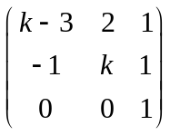,then the linear system AX=0 have a non-trivial solution for
k =________________

- If the matrix 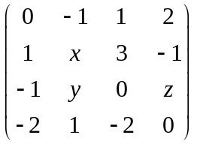 is skew-symmetric, then the values of x, y and z respectively are ________, _______ and __________

- The volume of the parallelepiped spanned by vectors A=(-2,2,1) ,B =(0,1,0) and
C = (-4, 3, 2) is ________________

- For a positive integer if
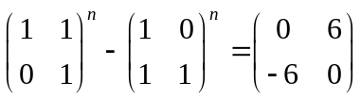, then = ______________

Part II. Attempt all the problems and show the required steps clearly. [25 points]

- Show that 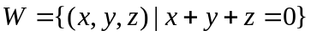 is a subspace of . (3 pts.)

- Given A =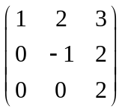. Find
- all eigenvalues and corresponding eigenvectors of matrix A. (3 pts.)
- inverse of A. (3 pts.)

- a) Find the equation of the line of intersection of the planes 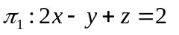and
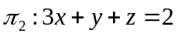. (3 pts.)
- Find the distance between the line in part (a) and the point Q = (1, 0, 0). (2 pts.)

- Show that the vectors form basis of .Find
coordinate vector of (1, 2,3) with respect to this basis. (4 pts.)

- (a) Determine all values the constant b for which the system

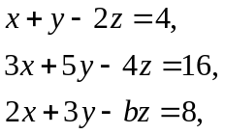

has i) a unique solution, (2 pts.)
ii) an infinite number of solutions, (2 pts.)

(b) Find the solution sets in part (a) (i) and (ii) (3 pts.)

